Calibration of the LVX2000

- Using the Nozzle Location Editor
- Calibration of the Laser and Nozzle Scan Heights
- Calibration of Machine Offsets
  - by the Laser
  - by the Fine Pitch Camera
- Setting Offset Angle
  - of the Laser
  - of the Fine Pitch Camera

1. Using the Nozzle Location Editor
Teaching the X,Y Nozzle Position
- Select the Nozzle Location Editor option from the Editors menu. The window shown in figure 1 will be displayed.
- Click the nozzle #1 (or #2, #3, #4, #5) field located on the displayed table.
- Click the Center On option to Camera.
- Click the Move To X,Y button and the machine will move over the programmed position for this nozzle.
- Using the jog panel, adjust the head position, as needed, so that the camera cross-hair is centered over the nozzle.

TIP: By placing a mirror or really any reflective object under the nozzle rack, it is easy to see the center of the nozzle hole with the camera.

- Click on the Save X,Y button.
- Repeat steps two through six for each of the other nozzles.
Teaching the Z for Nozzle Pick Up

TIP: The user should get into the habit of physically crouching down to the machine nozzle level while teaching critical operations like z heights. Observing the machine at the working level instead of standing over it will reveal much more detail on how the machine is operating.

- Click the Center On option to Head.
- Click Move to X,Y. The head will move over nozzle #5 (or #4, #3, #2, #1).
- Using the Jog Panel, carefully move the head down switching to a low speed as the head approaches the nozzle. Continue to move the head down until an audible click is heard. This click should be just when the nozzle snaps into the nozzle holder.
- Click on Get Z.

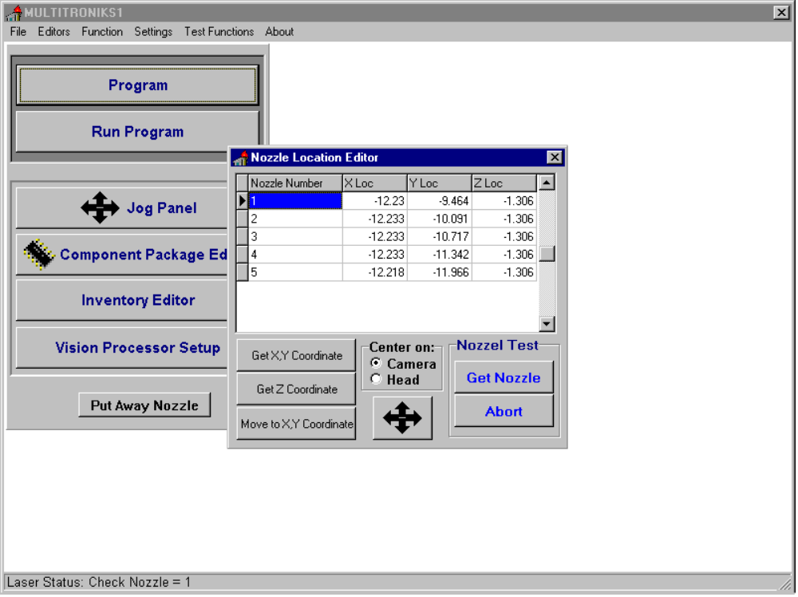

Figure 1

- Because the Z Location should be the same for all nozzles use the value found in the previous step for all nozzles. The user may manually type or use the mouse to copy and paste the Z value for each nozzle.
- Test each nozzle pick position by alternately using the Get Nozzle and Put Nozzle button. When properly taught, picking and placing nozzles will be a quiet and smooth operation.

2. Calibration of the Laser and Nozzle Scan Heights
Finding the Nozzle scan Height
- Choose the Laser Calibration option from the Function menu. The window pictured in figure 2 will be shown.
- Click the nozzle #1 (or #2, #3, #4, #5) field located on the displayed table.
- Click the Get Nozzle button. The machine will pick up the selected nozzle.
- Click the Find Scan Height button. This will start an automatic search procedure to zero in on the z value so that the edge of the nozzle is one step above the plane of the laser.
- The program will return a value and prompt the user to save or discard. Click on Yes to save.
- Click on the Put Nozzle button to return the nozzle to the holder.
- Repeat steps three through six for the other four nozzles.

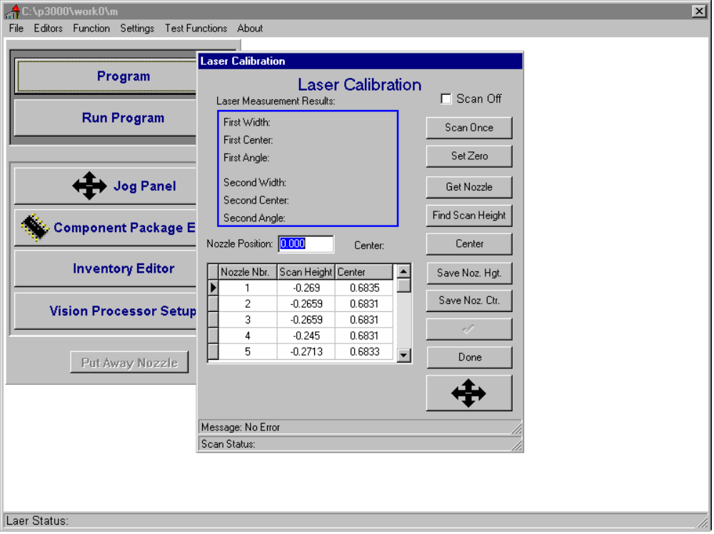

Figure 2

Finding the Nozzle Center.
- Click the nozzle #1 field located on the displayed table.
- Click the Get Nozzle button. The machine will pick up the selected nozzle.
- Click the Center button. This will start an automatic search procedure to find the center of the nozzle or to be more specific it will find the rotating center of the theta axis.
- The program will return a value and prompt the user to save or discard. Click on Yes to save.
- Because the rotating center of the theta axis is the same for all nozzles use the value found in the previous step for all nozzles. The user may manually type or use the mouse to copy and paste the Center value for each nozzle.
- Click on the Put Nozzle button to return the nozzle to the holder.
- Click the Done button to close the Laser Calibration menu.

3.1 Calibration of Machine Offsets by the Laser

NOTE: Users that have machines equipped with an upward looking camera should skip this section.
TIP: For accurate picking of the calibration component and, therefore, accurate calibration, the user should check the calibration component’s holder for any debris and clean as needed.

- Select the Calibration option from the Function menu.
Setting up the Calibration Component Parameters
- Click the Calibration Coordinate tab. The window pictured in figure 3 will be shown.
- Click the Center On option to Camera and the Calibration option to Pick Point.
- Click the Move To button. The camera will move over the programmed position.

TIP: If the component is sitting to one side in its holder (not centered) the user may manually move the component. If the component is centered manually step five may be skipped.

- Using the jog panel adjust the position so that the cross hair is approximately centered. Click the Save X,Y button.
- Click the Calibration option to Place Point. Click the Save X,Y button.

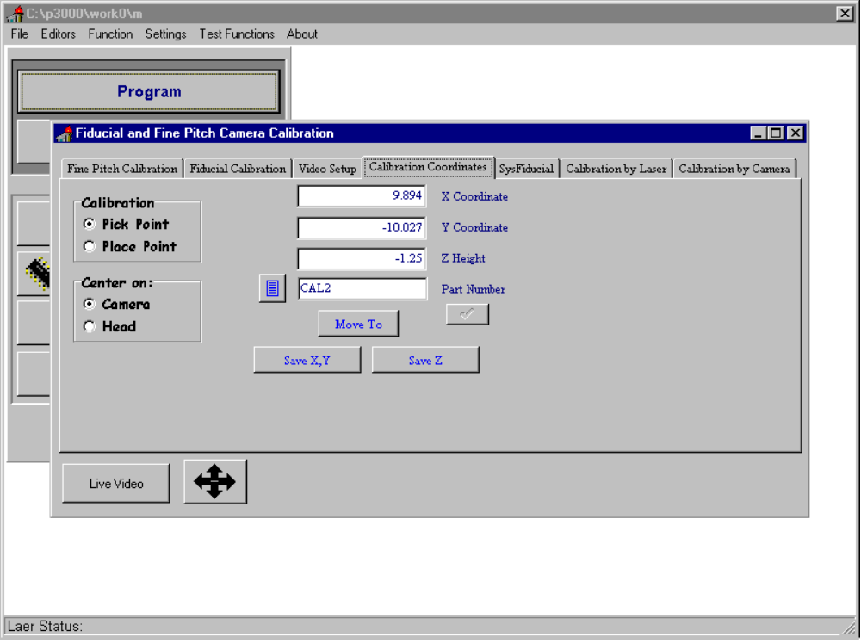
Figure 3

Running the Calibration Procedure
- Click the Calibrate by Laser tab. The window pictured in figure 4 will be shown.
- Click the Start button to begin the automatic calibration. The machine will analyze the top of the calibration component with the fiducial camera and then pick the component. The component will be analyzed by the laser. Finally the component will be put back in its holder.
- The program will return values and prompt the user to save or discard. Typically, the user should click on the Save button.

NOTE: Among the many returned values there are two that are very important. The dx and dy, located on the lower right status bar. These values will approach zero each time the calibration is run. A good calibration will return -0.0005< dx <+0.0005 and -0.0005< dy <+0.0005.

- Repeat steps eight and nine until dx and dy are within specification.
- Close the Calibration window.
- Select the Initialize option from the Function menu. Then select the Initialize Motors option.

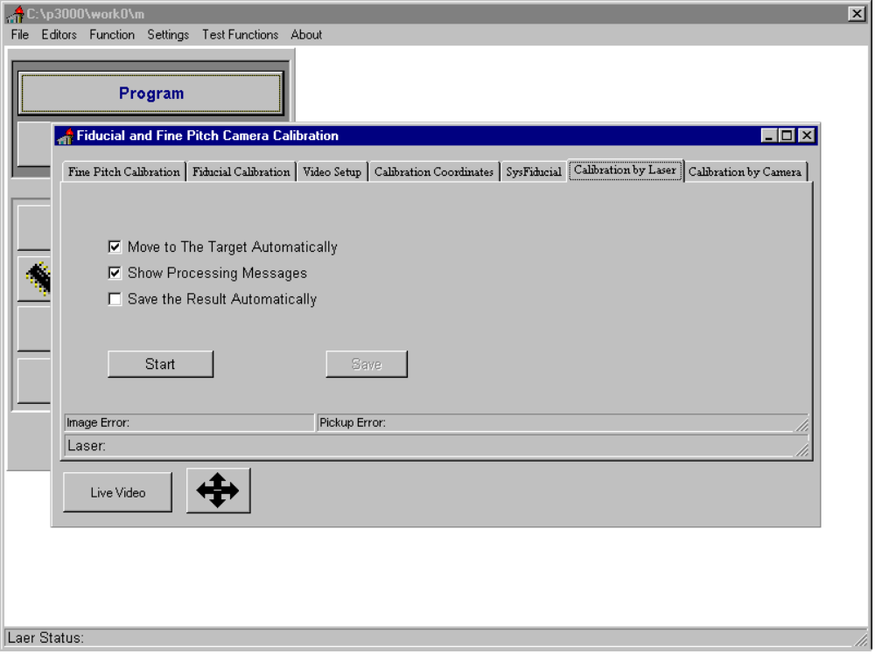

Figure 4

- Calibration of Machine Offsets by the Fine Pitch Camera

NOTE: This section only applies to machines equipped with an upward looking camera.
TIP: For accurate picking of the calibration component and, therefore, accurate calibration, the user should check the calibration component’s holder for any debris and clean as needed.

- Select the Calibration option from the Function menu.
Setting up the Calibration Component Parameters
- Click the Calibration Coordinate tab. The window pictured in figure 3 will be shown.
- Click the Center On option to Camera and the Calibration option to Pick Point.
- Click the Move To button. The camera will move over the programmed position.

TIP: If the component is sitting to one side in its holder (not centered) the user may manually move the component. If the component is centered manually step five may be skipped.

- Using the jog panel adjust the position so that the cross hair is approximately centered. Click the Save X,Y button.
Running the Calibration Procedure
- Click the Calibrate by Camera tab. The window pictured in figure 5 will be shown.
- Click the Start button to begin the automatic calibration. The machine will analyze the top of the calibration component with the fiducial camera and then pick the component. The component will be moved to the upward looking camera and analyzed. Finally the component will be put back in its holder.
- The program will return values and prompt the user to save or discard. Typically the user should click on the Save button.

NOTE: Among the many returned values there are two that are very important: the dx and dy, located on the lower right status bar. These values will approach zero each time the calibration is run. A good calibration will return -0.0005< dx <+0.0005 and -0.0005< dy <+0.0005.

- Repeat steps eight and nine until dx and dy are within specification.
- Close the Calibration window.
- Select the Initialize option from the Function menu. Then select the Initialize Motors option.
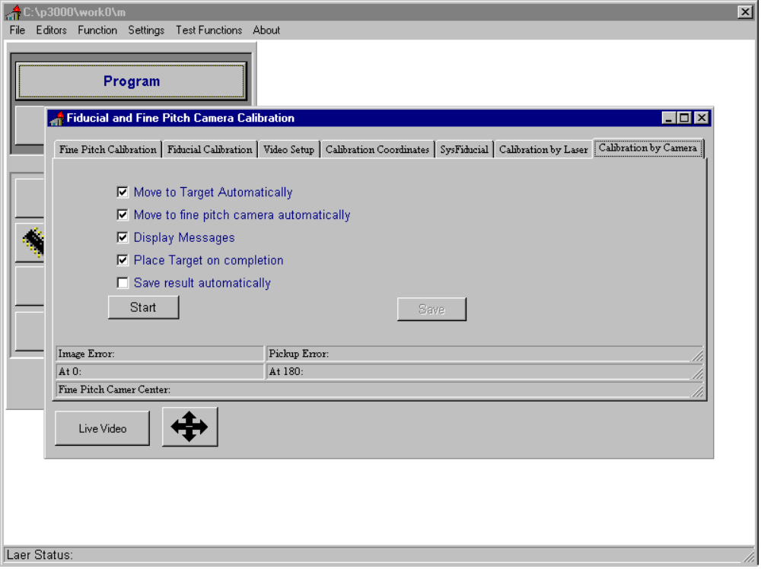

Figure 5

- Setting the Offset Angle –

TIP: Setting the offset angle is a trial and error procedure. The procedure is best done with a large QFP and a board having pads very similar in width as the leads on the QFP. This will allow any small angular error to be intensified for ease of visual inspection. To help guaranty accurate placement use a large nozzle; increase the place delay beyond what might normally be necessary; slow the head speed to fifty percent; and recheck part thickness and board base height. Weak double sided tape is also very useful for test placing one part multiple times.

- Setting the Offset Angle of the Laser
Setting up a QFP for Test Placement
- Assuming this a new part, define the package parameters as described in section 5.2.1. Set the Analysis Device to Laser. Define the inventory item as described in section 5.2.2. Define the feeder as described in section 5.2.3.
- Assuming this is a new board, define the board alignment and fiducial information as described in section 5.2.5. Using the Component Placement Editor teach the placement position of the qfp as described in section 5.2.6.
- Test place the part and adjust the X,Y placement as needed using the jog panel and the Register X,Y button.
Angular Error Correction Procedure
- Remove the part from the board and test place.
- Any angular error should be evident by viewing the leads to pads placement with the camera and jog panel.

NOTE: A left or counter clockwise (CCW) turn will require a decrease in the Laser Angle Offset parameter. A right or clockwise (CW) turn will require an increase in the Laser Angle Offset parameter. Typically, only a fraction ( maybe one tenth) of a degree change is all that is needed.

- Select the System Settings option from the Settings menu.
- Click the Laser tab. Figure 6 will be shown.
- Click the Laser Angle button and adjust the laser angle as needed by manually typing a value in the text box. Click the post button (check mark).
- Repeat steps four through eight until the part is consistently placed with no angular error.

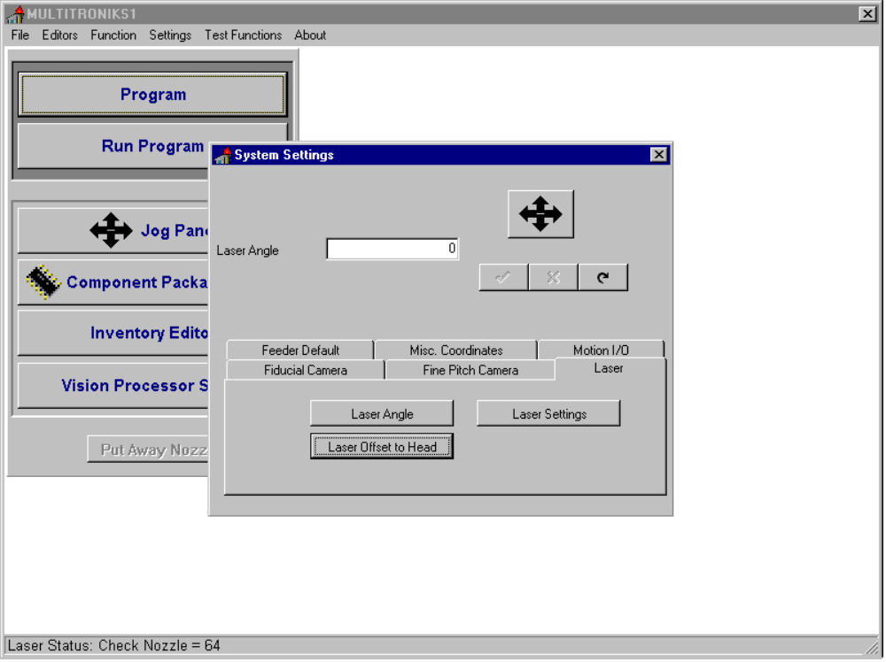

Figure 6

4.2 Setting the Offset Angle of the Fine Pitch Camera

NOTE: This section only applies to machines equipped with an upward looking camera.

Setting up a QFP for Test Placement
- Assuming this a new part, define the package parameters and lead information as described in section 5.2.1. Set the Analysis Device to Fine Pitch Camera. Define the inventory item as described in section 5.2.2. Define the feeder as described in section 5.2.3.
- Assuming this is a new board, define the board alignment and fiducial information as described in section 5.2.5. Using the Component Placement Editor teach the placement position of the qfp as described in section 5.2.6.
- Test place the part and adjust the X,Y placement as needed using the jog panel and the Register X,Y button.
Angular Error Correction Procedure
- Remove the part from the board and test place.
- Any angular error should be evident by viewing the leads to pads placement with the camera and jog panel.

NOTE: A left or counter clockwise (CCW) turn will require a decrease in the Camera Angle Offset parameter. A right or clockwise (CW) turn will require an increase in the Camera Angle Offset parameter. Typically, only a fraction ( maybe one tenth) of a degree change is all that is needed.

- Select the System Settings option from the Settings menu.
- Click the Fine Pitch Camera tab. Figure 7 will be shown.
- Click the Camera 2 Coordinates button and adjust the camera angle as needed by manually typing a value in the text box. Click the post button (check mark).
- Repeat steps four through eight until the part is consistently placed with no angular error.

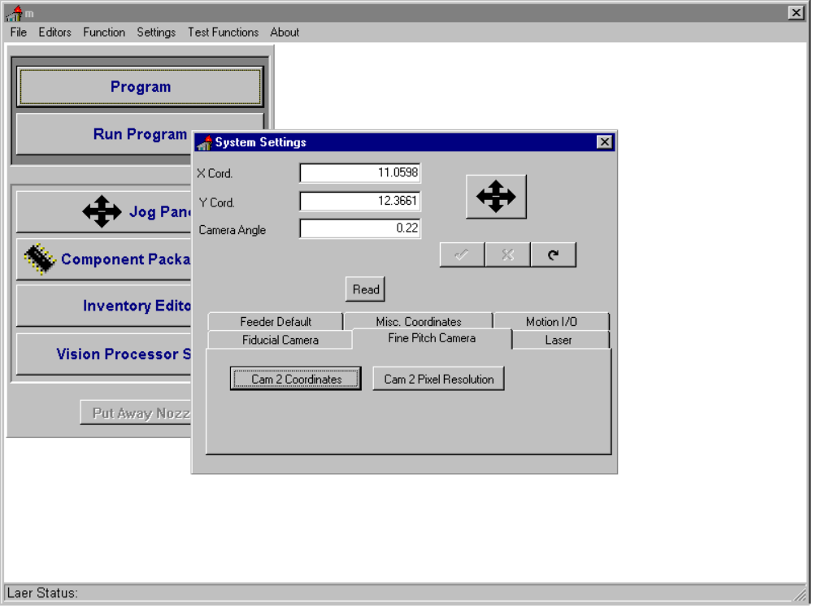

Figure 7

At this point your machine is calibrated and is advisable to make a back up of your system.

